LABORATORY OBSERVATION/RECORD
Course: Full Stack Web Development
Course Code: 23CM4121
Task No.: 1
Student Name: EMANDI HARI CHARAN
Roll No.: A24126552080
Date:31-07-2026

OBSERVATION TASK 1: HTML5 DOCUMENT STRUCTURE, FORMS, MULTIMEDIA, AND TABLES

PART A: College Information Portal - Document Structure, Formatting & Lists
Task Requirement:
Develop an HTML page titled 'College Information Portal' containing institute overview, text formatting examples (bold, italics, underline, subscript, superscript), ordered list of programs, unordered list of campus facilities, and external hyperlinks.
part_A.html
<!DOCTYPE html>
<html lang="en">
<head>
<meta charset="UTF-8">
<meta name="viewport" content="width=device-width, initial-scale=1.0">
<title>College Information Portal</title>
</head>
<body>
<!-- ================= HEADER ================= -->
<header>
<h1 align="center">College Information Portal</h1>
<hr>
</header>
<!-- ================= NAVIGATION ================= -->
<nav align="center">
<a href="#about">About</a> |
<a href="#courses">Courses</a> |
<a href="#students">Student Details</a> |
<a href="#registration">Registration</a> |
<a href="#media">Media</a> |
<a href="#contact">Contact</a>
</nav>
<hr>
<!-- ================= PART A ================= -->
<section id="about">
<article>
<h2>About the College</h2>
<p>
<strong>Anil Neerukonda Institute of Technology and Sciences (ANITS)</strong>
is one of the premier engineering institutions in Andhra Pradesh,
dedicated to excellence in education, research, innovation,
and overall personality development of students.
</p>
<h2>Text Formatting Examples</h2>
<p><strong>Bold Text Example</strong></p>
<p><em>Italic Text Example</em></p>
<p><u>Underlined Text Example</u></p>
<p>
Water Chemical Formula:
H<sub>2</sub>O
</p>
<p>
Einstein's Equation:
E = mc<sup>2</sup>
</p>
</article>
</section>
<section id="courses">
<h2>Programs Offered (Ordered List)</h2>
<ol>
<li>Computer Science and Engineering</li>
<li>Artificial Intelligence & Machine Learning</li>
<li>Electronics and Communication Engineering</li>
<li>Electrical and Electronics Engineering</li>
<li>Mechanical Engineering</li>
</ol>
<h2>Campus Facilities (Unordered List)</h2>
<ul>
<li>Central Library</li>
<li>Computer Laboratories</li>
<li>Sports Complex</li>
<li>Innovation Center</li>
<li>Digital Classrooms</li>
</ul>
<h2>Useful Links</h2>
<p>
<a href="http://anits.org/" target="_blank">
Visit ANITS Official Website
</a>
</p>
<p>
<a href="https://www.google.com" target="_blank">
Visit Google
</a>
</p>
</section>
<hr>

Actual Output Screenshot - Part A:
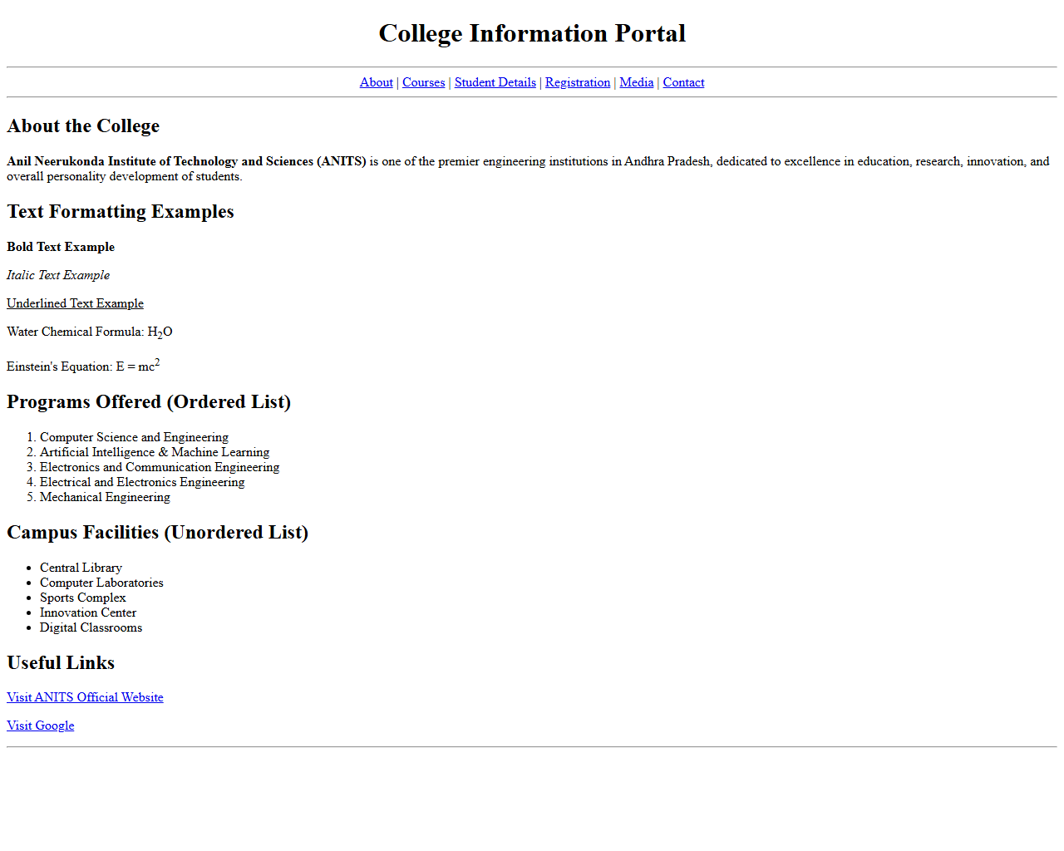
Result: Part A was executed and verified successfully. The HTML page renders college details, formatted chemistry/physics formulas, program lists, and hyperlinks cleanly.

PART B: Student Details Table & College Media Embedding
Task Requirement:
Create a structured HTML table displaying student details (Roll No, Name, Branch, Email) and embed image elements for college logo and college campus.
part_B.html
<!-- ================= PART B ================= -->
<section id="students">
<h2>Student Details</h2>
<table border="1" cellpadding="10" cellspacing="0">
<tr>
<th>Roll No</th>
<th>Name</th>
<th>Branch</th>
<th>Email</th>
</tr>
<tr>
<td>A24126552080</td>
<td>Hari Charan</td>
<td>CSM</td>
<td>hari@example.com</td>
</tr>
<tr>
<td>A24126552081</td>
<td>Rahul Kumar</td>
<td>CSE</td>
<td>rahul@example.com</td>
</tr>
<tr>
<td>A24126552082</td>
<td>Priya Sharma</td>
<td>AIML</td>
<td>priya@example.com</td>
</tr>
</table>
<br>
<h2>College Logo</h2>
<img src="college_logo.png"
alt="Official College Logo"
width="150">
<br><br>
<h2>College Campus</h2>
<img src="college_campus.png"
alt="College Campus Building"
width="500">
</section>
<hr>

Actual Output Screenshot - Part B:
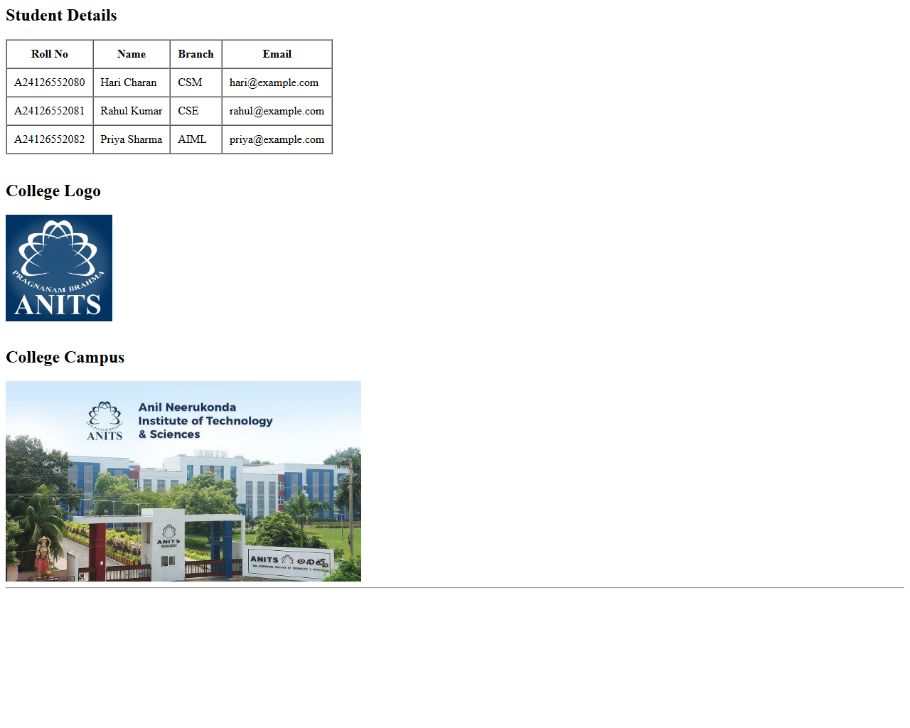
Result: Part B was executed and verified successfully. The student table renders with cell padding and borders alongside embedded college logo and campus images.

PART C: Student Registration Form
Task Requirement:
Design a complete Student Registration Form including text, email, password inputs, gender radio buttons, hobbies checkboxes, branch dropdown menu, comments textarea, submit, and reset buttons.
part_c.html
<!-- ================= PART C ================= -->
<section id="registration">
<h2>Student Registration Form</h2>
<form>
<label><strong>Student Name</strong></label><br>
<input type="text" placeholder="Enter your name" required>
<br><br>
<label><strong>Email Address</strong></label><br>
<input type="email" placeholder="Enter your email" required>
<br><br>
<label><strong>Password</strong></label><br>
<input type="password" placeholder="Enter password" required>
<br><br>
<label><strong>Gender</strong></label><br>
<input type="radio" name="gender"> Male
<input type="radio" name="gender"> Female
<input type="radio" name="gender"> Other
<br><br>
<label><strong>Hobbies</strong></label><br>
<input type="checkbox"> Reading
<input type="checkbox"> Coding
<input type="checkbox"> Sports
<input type="checkbox"> Music
<br><br>
<label><strong>Branch</strong></label><br>
<select>
<option>Select Branch</option>
<option>Computer Science and Engineering</option>
<option>Computer Science and Machine Learning</option>
<option>Artificial Intelligence & Machine Learning</option>
<option>Electronics and Communication Engineering</option>
<option>Electrical and Electronics Engineering</option>
</select>
<br><br>
<label><strong>Comments</strong></label><br>
<textarea rows="5" cols="50"
placeholder="Enter your comments"></textarea>
<br><br>
<input type="submit" value="Submit">
<input type="reset" value="Reset">
</form>
</section>
<hr>

Actual Output Screenshot - Part C:

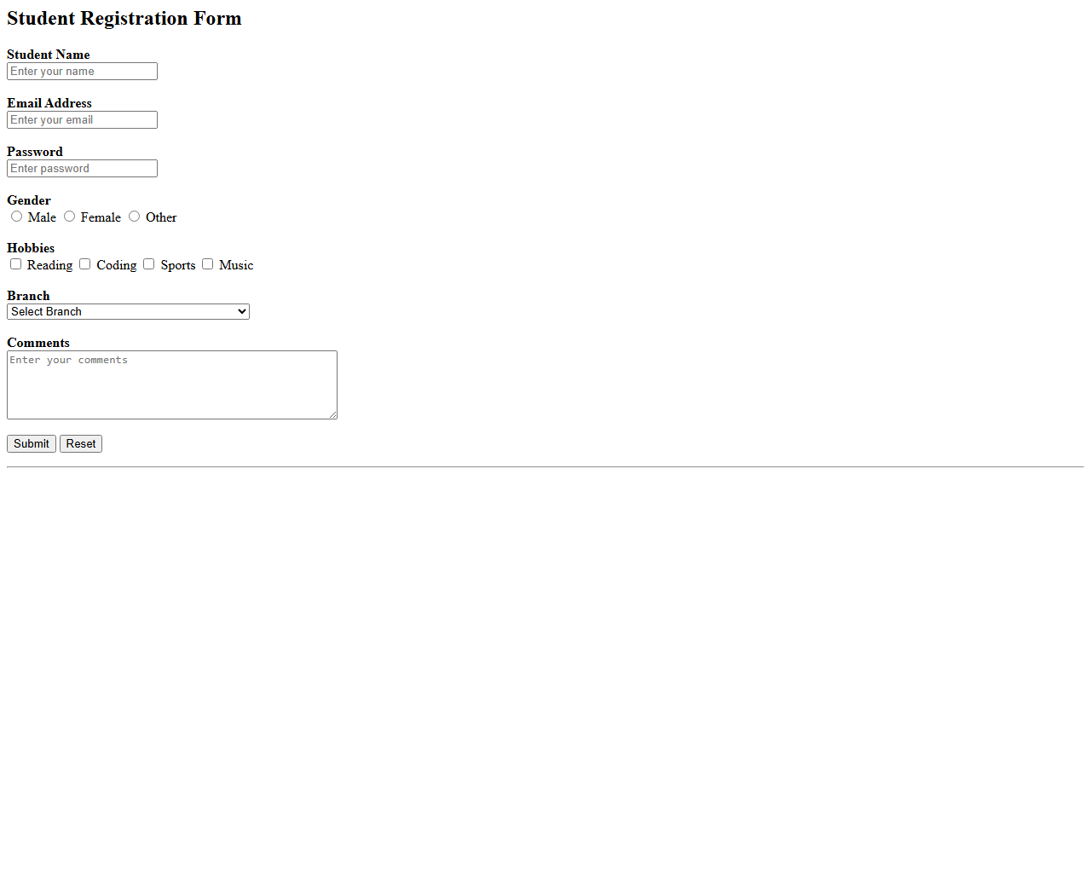
Result: Part C was executed and verified successfully. The registration form renders input fields, radio choices, checkboxes, dropdown select, and action buttons cleanly.

PART D: HTML5 Specialized Input Types & Audio/Video Controls
Task Requirement:
Demonstrate HTML5 input controls (email, date, number, color picker, range slider) and embed native HTML5 <audio> and <video> elements with playback controls.
part_d.html
<!-- ================= PART D ================= -->
<section id="media">
<h2>HTML5 Input Types</h2>
<form>
<label>Email</label><br>
<input type="email">
<br><br>
<label>Date of Birth</label><br>
<input type="date">
<br><br>
<label>Age</label><br>
<input type="number" min="18" max="60">
<br><br>
<label>Favorite Color</label><br>
<input type="color">
<br><br>
<label>Programming Skill Level</label><br>
<input type="range" min="0" max="100">
</form>
<br>
<h2>sample audio</h2>
<audio controls>
<source src="sample_audio.mp3" type="audio/mpeg">
Your browser does not support the audio element.
</audio>
<br><br>
<h2>sample video</h2>
<video width="600" controls>
<source src="sample_video.mp4" type="video/mp4">
Your browser does not support the video element.
</video>
</section>
<hr>
<!-- ================= FOOTER ================= -->
<footer id="contact" align="center">
<p>
<strong>College Information Portal</strong><br>
Anil Neerukonda Institute of Technology and Sciences (ANITS)<br>
Sangivalasa, Visakhapatnam, Andhra Pradesh - 531162
</p>
<p>
© 2026 ANITS. All Rights Reserved.
</p>
</footer>
</body>
</html>

Actual Output Screenshot - Part D:
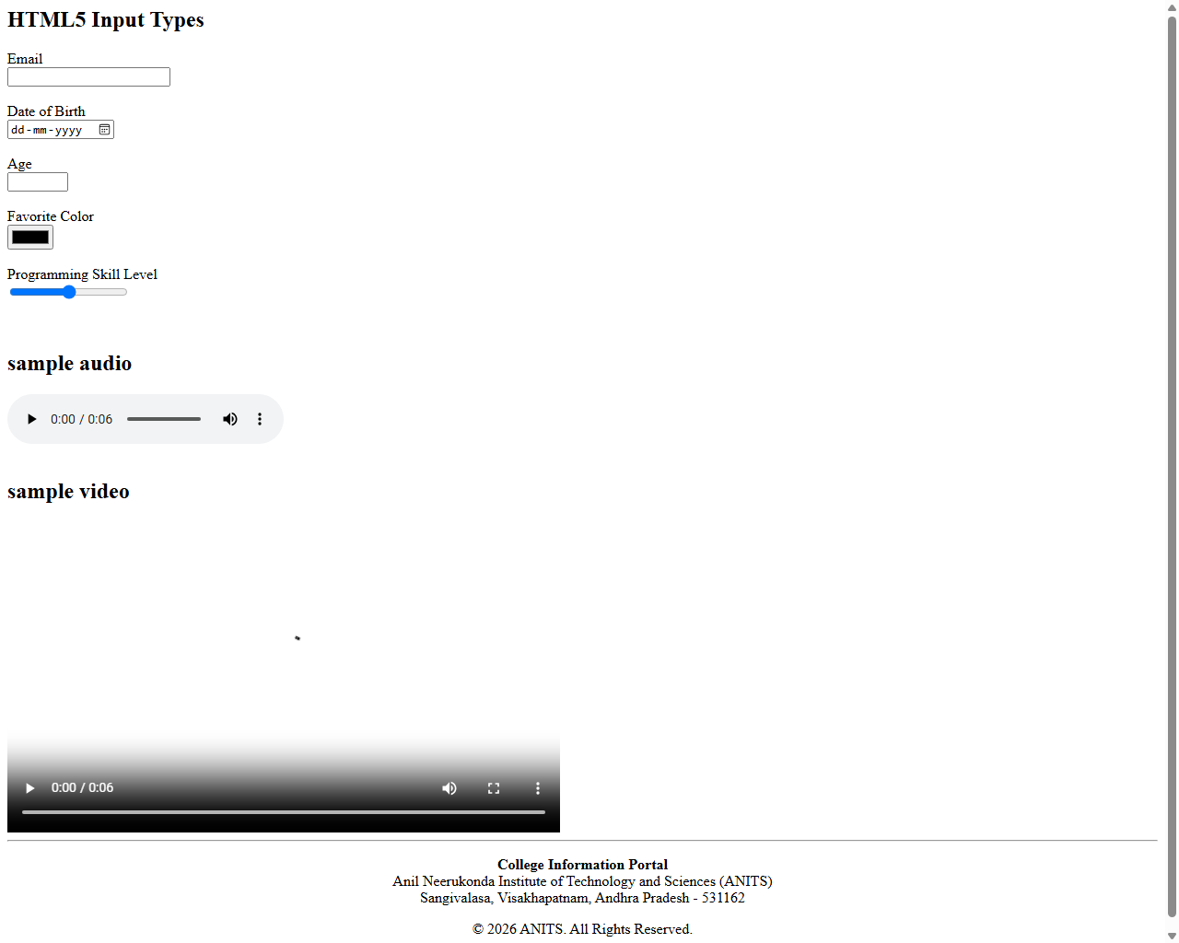
Result: Part D was executed and verified successfully. Specialized HTML5 input controls (date picker, color picker, range) and multimedia players render with native controls.

